1. Write a mapreduce program to find the total amount of petrol in volume sold by every distributor.
2. Write a mapreduce program to find which are the top 10 distributors ID's for selling petrol and also display the amount of petrol sold in volume.

DRIVER

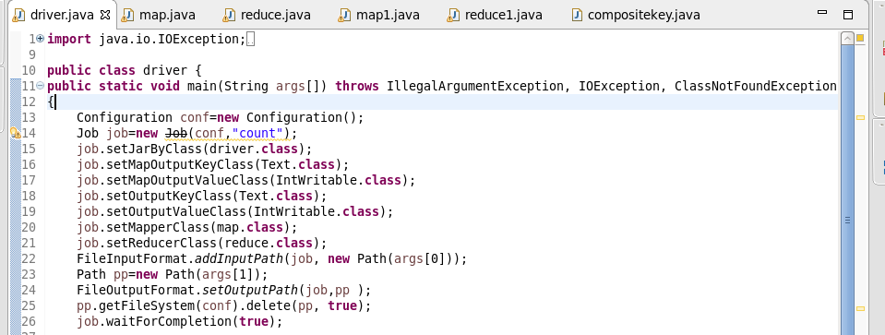

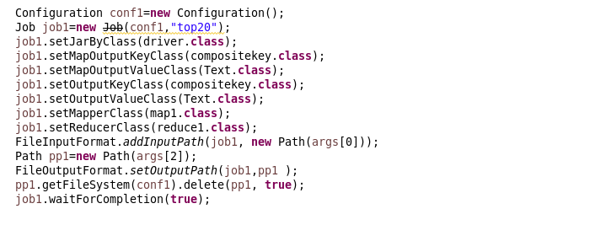

MAPPER FOR PROBLEM 1

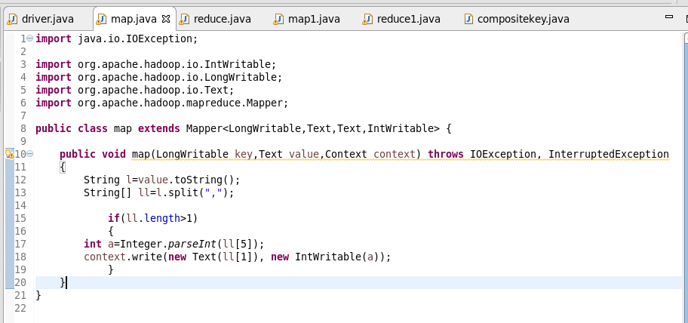

REDUCER FOR PROBLEM 1

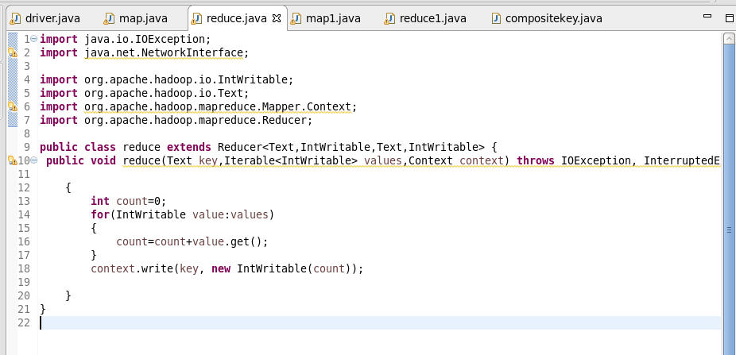

MAPPER FOR PROBLEM 2

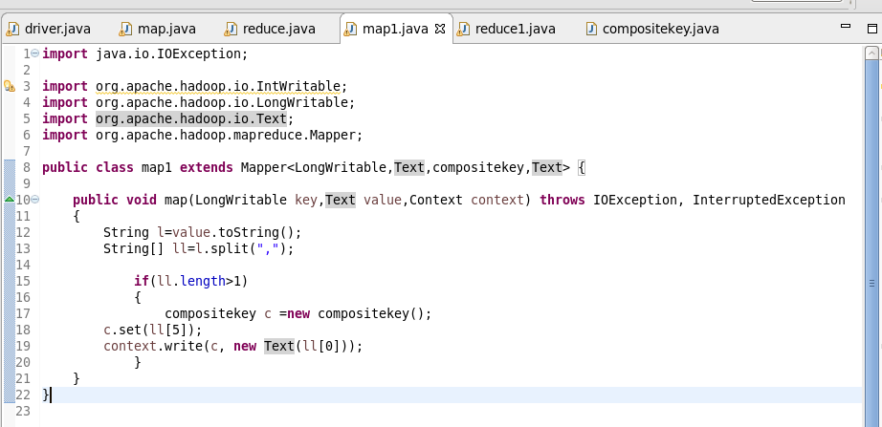

REDUCER FOR PROBLEM 2

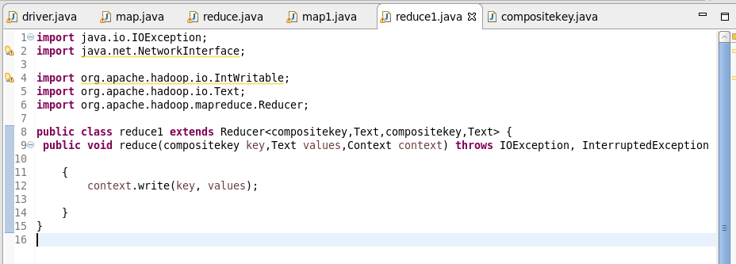

COMPOSITE KEY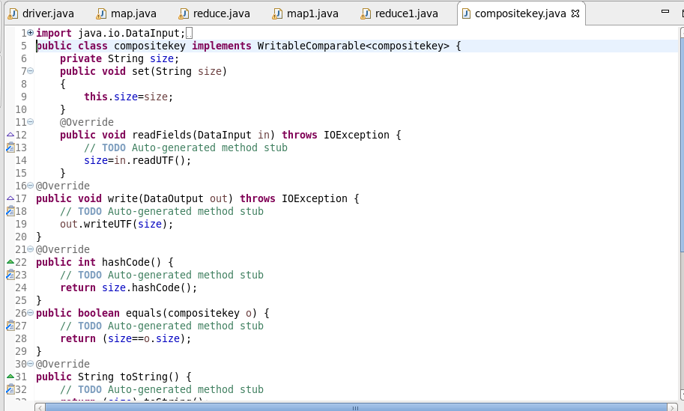

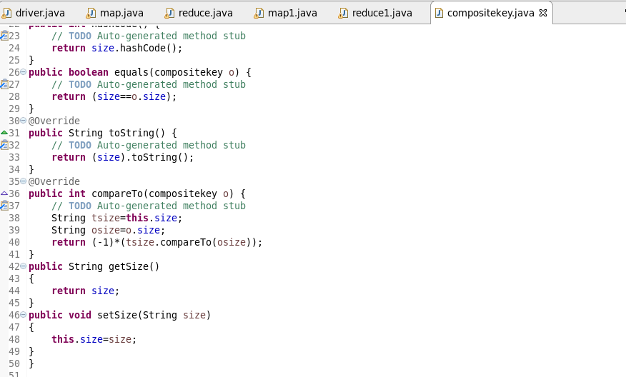

**OUTPUT FOR PROBLEM 1**

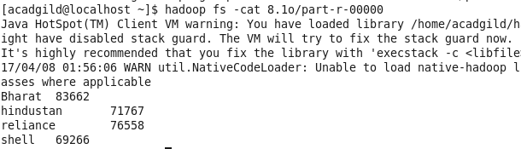

**OUTPUT FOR PROBLEM 2**

